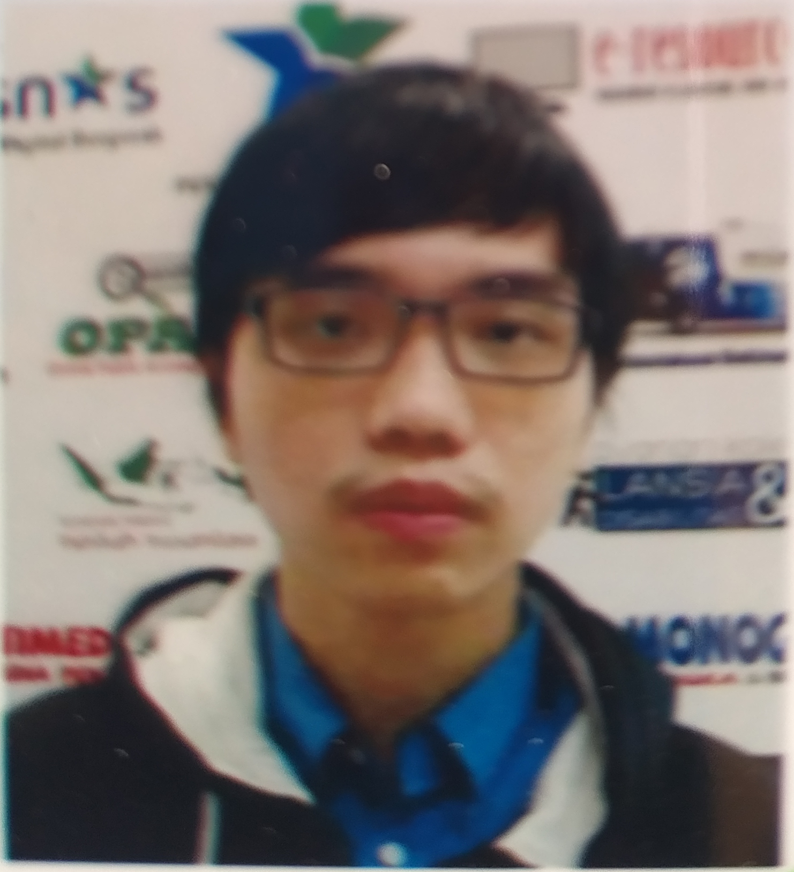

[Vincent Bernard]

West Jakarta, DKI Jakarta, 11250 **|** 087877142188 **|** vincent.bernard.job@gmail.com

LinkedIn: [www.linkedin.com/in/vincentbernardlin](http://www.linkedin.com/in/vincentbernardlin)

Website: <https://vincentbernardgit.github.io/portfoliowebsite/>

**Summary**

My name is Vincent Bernard, a final year Computer Science student at Bina Nusantara University. Have experience as a web programming instructor at Bina Nusantara Computer Club. Have experience as an application developer intern at PT Freeport Indonesia. Have accomplished Microsoft Certified Fundamentals as one of competency development training topics in Fresh Graduate Academy (FGA) organized by the Ministry of Communication and Information Technology. I am interested in developing the frontend and backend of websites as a full stack software engineer.

**Tools & Skills**

|  |  |
| --- | --- |
| * HTML5 * CSS: CSS3, Bootstrap 4 * JavaScript: jQuery, React * PHP: Laravel | * C#: ASP.NET * SQL Server * Adobe Photoshop CC |

**Work Experience**

**PT Freeport Indonesia (Jakarta, Indonesia)**

*Application Developer Intern* (February 2020 - February 2021)

Programming languages/frameworks/tools: HTML5, CSS3, Bootstrap 4, JavaScript, jQuery, SQL Server, ASP.NET, Azure

Tasks:

* Optimize and enhance features and functions to improve user experience regarding users requirements.
* Conduct a test to ensure all changes fulfill the users expectations.
* Data reporting and monitoring related to publishing applications to create a complete documentation covering all changes.
* Report all development progress to the Head of Application Infrastructure to make sure the progress is on track.

**Organization Experience**

**Bina Nusantara Computer Club** **(Jakarta, Indonesia)**

*Praetorian* (2018 - 2019)

Programming languages/frameworks/tools: HTML5, CSS3, Bootstrap 4, JavaScript, jQuery, Laravel, SQL Server, XAMPP

Tasks:

* Deliver web programming fundamentals to students.
* Train the students to build a web-based application using HTML, CSS, and JavaScript as the frontend, Laravel as the backend, and SQL Server to construct the database.
* Responsible for the student assessment based on take home assignments, project, and attitudes.
* Discuss about the project topic, assessment, and execution with other praetorians for students as one of graduation requirements.

**Education**

**Bina Nusantara University** **(2017 - now)**

*Bachelor of Computer Science - Current GPA 3.19*

* Participated as a web programming instructor at Bina Nusantara Computer Club.

**SMA Ricci 1 (2014 - 2017)**

*Science Major*

* Participated in the Red Cross as the facility coordinator.